Holiday/Christmas Party for FWSA Members and Guests
Hard 8 BBQ, Burleson TX (Pay individually as you enter)
December 5, 2021; 4:00-7:00 p.m.
Events:
- Dinner
- Silent Auction (Raising Funds for future FWSA events) Closes at 6:30 p.m.
  - Cash, Check or Credit Card
- Gift Exchange ($20 max) – Please designate gifts: Female or Male

PARTIAL INVENTORY OF AUCTION ITEMS ( ATTEND THE FWSA PARTY TO SEE ALL THE ITEMS):

Items 1: Older Apple Tablet: Mini Apple IPAD 4th generation; works like new. Great for practice recording, tuning, etc…power adapter included and standard installed Apple Tablet Software.

Item 3. Mixer: Peavey Unity Series 2000 – 12 inputs; good condition; Manual and travel case included.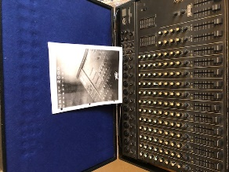

Item 4: 6 String Steel Guitar; Brand – Artisan; slide and travel cases
included.
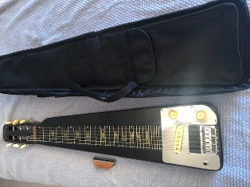

Item 5: Pro-Series 6-String Guitar; made in America by Travel Guitar; this guitar is designed for travel and include the original instruction book and travel case.
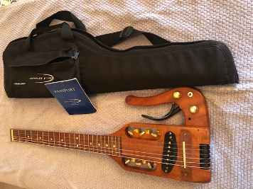

HOME

Item 6: Yamaha Acoustic Guitar, Model F310; good shape/good sound with guitar stand.
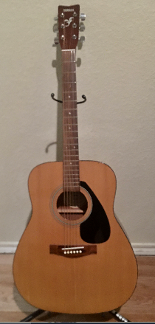

Item 7: 1st Act Beginner Guitar; good shape/good sound; perfect for a beginner.
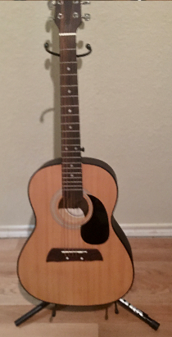

Item 8: Electric ‘no brand name’ but a good practice or starter guitar. Shape is similar to one of the popular model made by Fender.
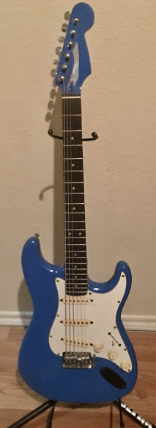

Item 9: Gift certificate for ONE (1) month of lessons on any instrument including interactive internet site. On site lessons at Sparks Music at the Hulen Mall.
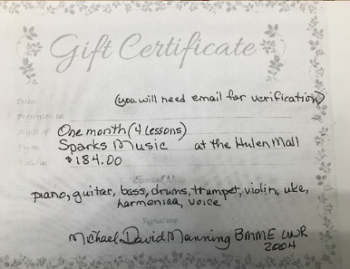
HOME

Item 10: Longhorn Wall Decoration right out of the ‘old west’.

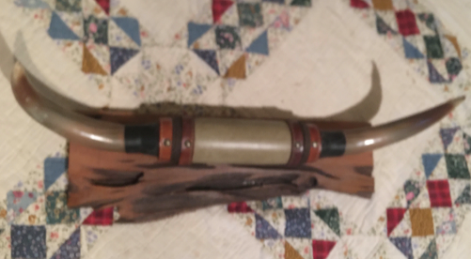

Item 11: A mountain Dulcimer made by The Dulcimer Factory in Fredricksberg, Texas; vintage 1990’s.
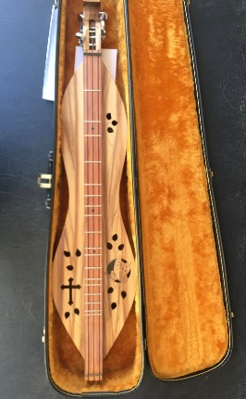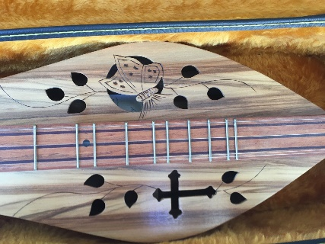

Item 12: Nice selection of costume Jewelry.
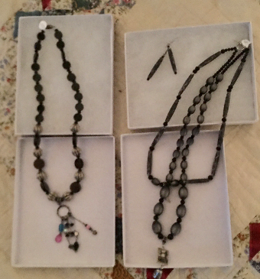

Item 13. 4 – 12” Speaker cabinet with Acoustic Amplifier System – Acoustic Lead Guitar Series G120H DSP 120W Guitar Amp Head; excellent working condition; minor scuff marks.

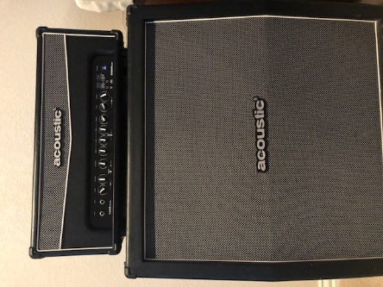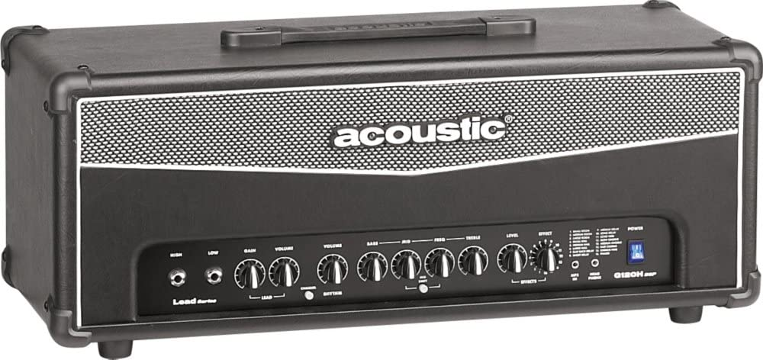
HOME

https://fwsa.com/home
Item 14. Older Apple Tablet, a 10” Apple IPAD 4th generation, works like new. Great for practice recording, tuning, etc…power adapter included and standard installed Apple Tablet Software.

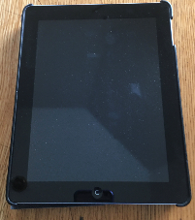

Item 15. Hand knitted alpaca cowl.

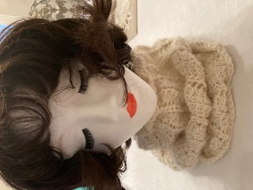

Item 16. Lady’s ear warmer.

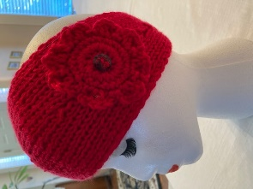

Item 17. Children’s ear warmers.

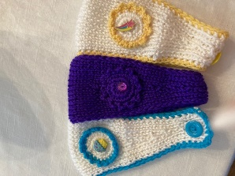

Item 18. Hand knitted hat and neck warmer.

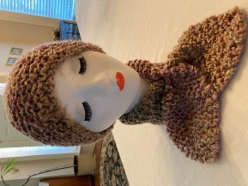

HOME

Item 19, Hanger kitchen towels.

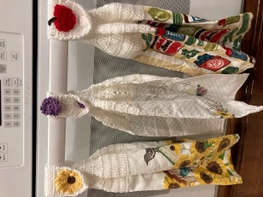

Item 20. Looper – Like new!
- Store and recall up to 99 of your favorite loop sessions
- 60-minute recording time means you’ll never run out of space for loops
- DITTO mode retains all functionality and control from our original DITTO looper pedal
- Extend loop mode lets you lay down long dubs over short loops
- Auto Cue in Extend Loop Mode allows for easy wrap-around timing

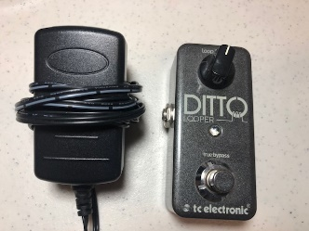

Item 21. This auction item is for 12 Boss FS-5U nonlatching footswitches designed to meet any need for a footswitch that engages the effect only for the time your foot is on it, like sustain or spot delay. Boss builds the Fs-5U to be compact, lightweight, and tough….currently listed on Amazon for $41.99 each. This item was being used in a band in support of digital drums. Complete with cables and a connector panel.

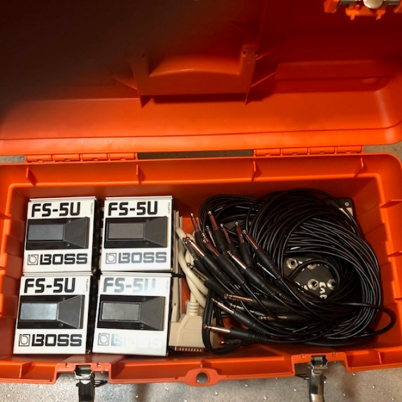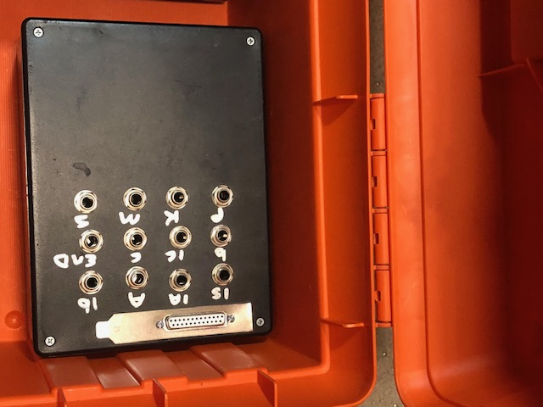

HOME

Item 22. Audio-Technica Proformance R80 Wireless Receiver w/T87 Transmitter good Condition. Minor scratches, scuffs and wear (Manual available online). Worked last time used.

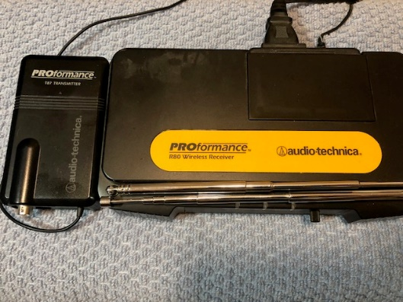

Item 23. Fender Squire Telecaster, SN ICO40933193. Vintage 2000’s, beautiful mahogany stained, designed and backed by Fender in Indonesia. Like new condition w/Case.

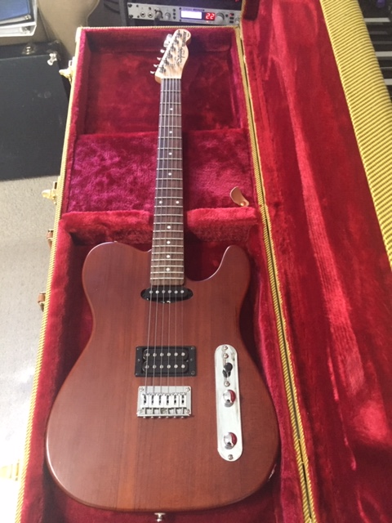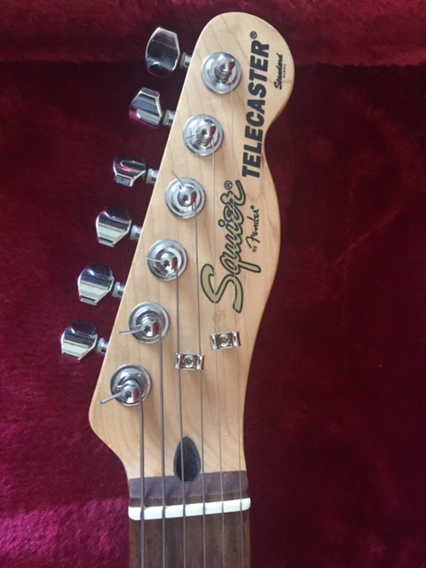

HOME
Item 24. Hand knitted faux fur scarf.

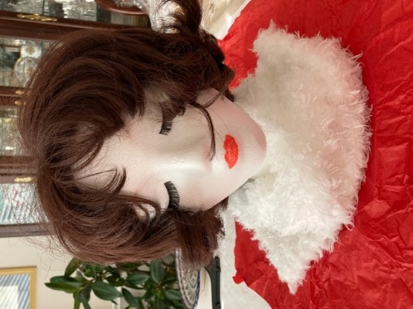

Item 25. Hand knitted faux fur scarf.

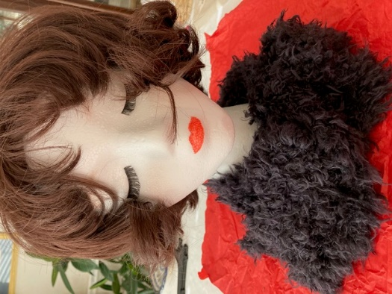

HOME

